Nepal College of Information Technology
Unit Test
Fall 2012
Program : BE ELX Time : 2 hrs
Semester : (III) FM : 70
Subject : Network Theory PM : 35

- Candidates are requested to give their answer as far as practicable in their own words.
- The figure in the margin indicates the full marks
- Attempt ALL question

1. a) Switch K is moved from position a to b at t=0.find the solution for i(t)through inductor at t=o. (8)

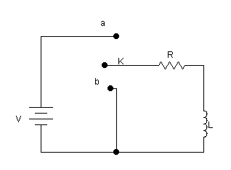
b) The switch is moved from b to a at t=0.find the solution for i(t) through inductor at t=0. (7)

2. a) Fig. shows a network which is assumed to be in the steady state before the operation of K. Find the expression for the current I, when the switch is:
i) initially open but closed at t=0.
ii) initially closed but opened at t=0. (7)
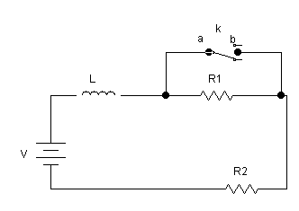
b) Find the solution i(t)for the given equation subjected to the following initial condition.i(0+)=2 and di/dt(0+)=0.

i''(t)+10i'(t)+25i(t) =0

3. a) Find the expression for i(t) at t=0. (7)
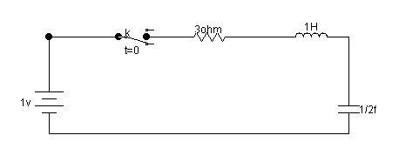

b) V=10v ,R=10 ohm,L=1H, C=1F and Vc(0)=0.
Find I(0+),dI/dt(0+)and2I/dt2(0+) (8)
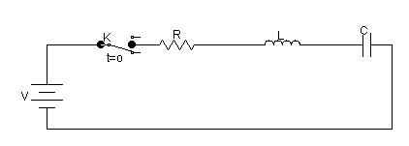
4. a) In the network ,switch is opened at t=0,after having been closed for a long time. Find I through inductor for t>0 and evaluate I at 20ms. (7)
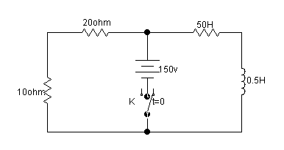
b) Find the expression for loop current I at t=o. The switch K is closed at t=o. (8)
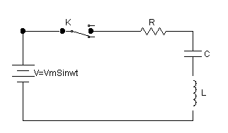
5. Write short notes on
i) Transient response and steady state.
ii) Laplace transform

